Chapter 15, Solution 8.

- 2t=2(t-4) + 8
f(t) = 2tu(t-4) = 2(t-4)u(t-4) + 8u(t-4)
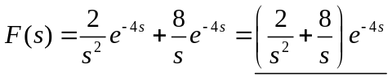
(b) 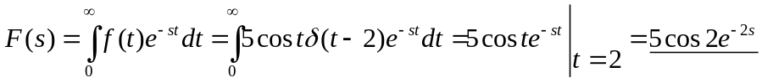
5cos(2)e^{–2s}

(c) 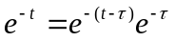
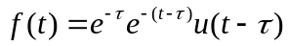
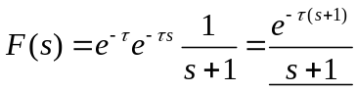

(d)
